OpenMoko Dialer Design 2

- Overview
This article defines the Dialer Application, an application designed for the OpenMoko platform. The Dialer Application handles all call and SMS related interactions. This is a Native Finger-Based application.
In this article, let’s call the application a Phone App.
  - Functions
To dial a number and call out
To accept an incoming call
To redial last dialed number
To adjust the volume of the speaker or microphone
To view the history
  - Features
Autocompletion- Automatically complete the tail of phone numbers from existing contacts (when matched).
List Possible Autocompletions -- A list of numbers that can be autcompleted. These are buttons that, when pressed, will autocomplete the current number string.
DTMF Support—Send DTMF codes in connection.

- Layout Design
Please refer to:
http://wiki.gta01.hmw-consulting.de/index.php/Dialer#Layout_Components
- Architectural Overview
3.1 Phone Application Architecture
Other Apps
Phone Daemon
Incoming Dialogue
Outgoing Dialogue
In-call Dialogue
Dialer Dialogue
History Dialogue
Libmokonet, libmokocore, libmokoui, libmokopim…
Phone App
Contacts API
D-bus Messages
History API/Common MessageBox
Phone App integrates all the phone-call related functions, but it doesn’t include Contacts. Phone App only call contacts APIs to search/add contacts.
Many other apps might call phone functions. Phone Daemon will listen for such messages in the D-bus, and launch proper inner functions.

3.2. Sub-Functions & Communication
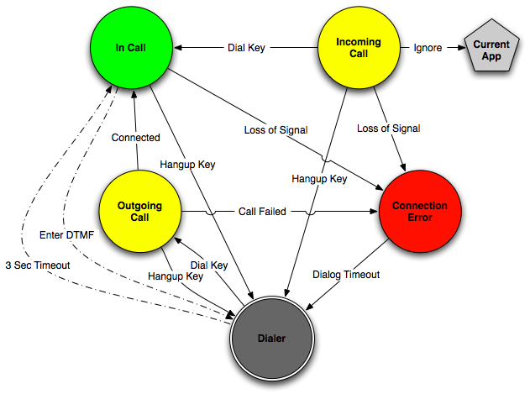
The controlling part is the Phone Daemon. It’s launched upon power on, after necessary initialization (including registering D-bus messages, initializing libmokonet, reading configuration info, and so on.), it will start listening
3.2.1 Phone Daemon Functions:
Initialize Phone-related API/configuration
Listen on D-bus messages
Launch Dialer Dialogue
Launch Incoming Call Dialogue
Launch Outgoing Call Dialogue
Show Dialer Dialogue
Hide Dialer Dialogue.
Signal to D-bus sending phone events
Incoming Call Message with the Number
Get contact information
Show Incoming Dialog
Answer
Ignore
Reject
Timeout
Caller Canceled
Update History
Hide Dialer, return
Y
N
Hangup
Volume Adjust
Show In-call Dialog
DTMF
Speaker
In-call
Update History
Hide Dialer, return
Caller Hangup
Diagram: Incoming Call Operations.
Dial a Number
User Dialing
Dial
History
Cancel
Show Outgoing Dialogue
Selected?
Show History
Return Previous App
Y
N
Cancel
Speaker
Error
Y
Return to Dialer

Return to Dialer

Update History
Connected
Show In-call Dialog
… (See the previous diagram )
Diagram: Out-coming Call Operations.

3.2.2 Dialer Dialogue Functions.
Dial a Number
Auto-complete
Display the contact images.
Launch History Dialogue
Redial (Remember last dialed number)
Signal to D-bus sending numbers dialed and allow the outgoing call dialogue show.

3.2.3 Outgoing Call Dialogue:
Disconnect
Speaker Phone
Listen to signals from D-bus related to libgsm.
Call contacts API to get the name of the dialing number, and show it.
Display the contact images.
If connected, signal the Phone Daemon to allow In-call Dialogue to show.
Call History APIs to update history.

3.2.4 Incoming Call Dialogue Functions.
Answer
Ignore
Reject
Listen to signals from D-bus related to libgsmd.
Call contacts API to get the name of the dialing number, and show it.
Display the contact images.
If connected, signal the Phone Daemon to allow In-call Dialogue to show.
Call History APIs to update history.

3.2.5 In-call Dialogue:
DTMF Input
Timing
Hang-up
Volume
Speaker Phone
Listen to signals from D-bus related to libgsmd.
Call History APIs to update history.

3.2.6 History：
Show the 3 types of the history records.
Export APIs.
4. Data Structure
/**
* @brief phone number entry for the contact structure in open dialer.
*/
typedef struct dialer_contact_entry {
int ID;///<the unique ID for an contact entry
char *desc; ///<the description of this entry,such as homenumber
char *content; ///<the content of this entry, such as 62495726
struct dialer_contact* next;
}DIALER_CONTACT_ENTRY;
/**
* @brief contact structure for open dialer.
*/

typedef struct dialer_contact {
int ID;///<the unique ID for an contact entry
char *name; ///<person name
DIALER_CONTACT_ENTRY * entry; ///<first number entry for the person

struct dialer_contact* next; ///<pointer to next contact
}DIALER_CONTACT;

/**
* @brief contacts list head structure.
*/
typedef struct dialer_contacts_list_head {
int length; ///<thguane number of contacts
DIALER_CONTACT *contacts; ///<package list head pointer
}DIALER_CONTACTS_LIST_HEAD;

- Interface
5.1 Internal Interfaces:
5.1.1 contacts api
/* initialize contacts list*/
int init_contact_list(DIALER_CONTACTS_LIST_HEAD * head);

/* initialize contacts list, fill in the entrys which includes ‘numbers’*/
int init_contact_list_with_string(DIALER_CONTACTS_LIST_HEAD * head, char* numbers);

/*search for the contact which has the provided numbers.*/
int search_contact(DIALER_CONTACT *contact, char* numbers);

/*release the contacts list*/
int release_contact_entry(DIALER_CONTACT_ENTRY* contactentry);

/*release contact*/
int release_contact(DIALER_CONTACT *contact);

/*release contact list*/
int release_contact_list(DIALER_CONTACTS_LIST_HEAD * head);

/*initialize contact list with virtual data, no pim interaction, just for debug*/
int init_contact_list_cmd(DIALER_CONTACTS_LIST_HEAD * head);

5.2 External Interfaces:
5.2.1 libnet related
/* Register an event callback handler with libgsmd */
extern int lgsm_register_evt_cb(struct lgsm_handle *lh,
evt_cb_func *cb, void *user);

/* Initiate an outgoing voice call */
extern int lgsm_voice_out_init(struct lgsm_handle *lh,
const struct lgsm_addr *number);

/* Accept incoming voice call */
extern int lgsm_voice_in_accept(struct lgsm_handle *lh);

/* Terminate outgoing (or incoming) voice call */
extern int lgsm_voice_hangup(struct lgsm_handle *lh);

extern int lgsm_set_spkr_level(struct lgsm_handle *lh,
u_int32_t level);

/* Mute call during voice call */
extern int lgsm_mute_set(struct lgsm_handle *lh, u_int8_t on);

/* Get information on whether voice call is muted or not */
extern int lgsm_mute_get(struct lgsm_handle *lh, u_int8_t *on);

5.2.2 libpim related

/* Get a specific phonebook entry and store it to 'pb'
* pb' is caller-allocated */
extern int lgsm_pb_get_entry(struct lgsm_handle *lh,
struct lgsm_pb_entry *pb);
/*Get a phonebook entry list according to the number offered*/
extern struct lgsm_pb_entry_list * lgsm_pb_list_get(struct lgsm_handle *lh, struct lgsm_pb_entry_list * pbl, char* number);

/*Get the contact name with the full number*/
extern char* lgsm_pb_list_get(struct lgsm_handle *lh, , char* number);

5.2.3 libui related
/*Show an auto-disappeared messagebox*/
extern int libui_show_message(int icontype, char* string, int timeout);

5.2.4 touchscreen related
/*register the tap with hold callback handler */
extern int register_on_tap_hold_callback(GtkWidget* widget, struct callback_handler ch*);

- Unresolved Issues:
  - DBus relatedAPIs definition.

